**AZ104 Project**

**Connecting Internet Workloads Using Vnet Peering and Assigning a Custom Role for Operating These Workloads**

**Course-end Project 2**

Step A: Create First Virtual Network in (East US) Region

CIDR VNET: 10.104.0.0/16, CIDR Subnet: 10.104.0.0/24

Resource Group Name: OSS_rg1_HQ

VNET Name: VNET1

Subnet Name: SN1

Location: East US

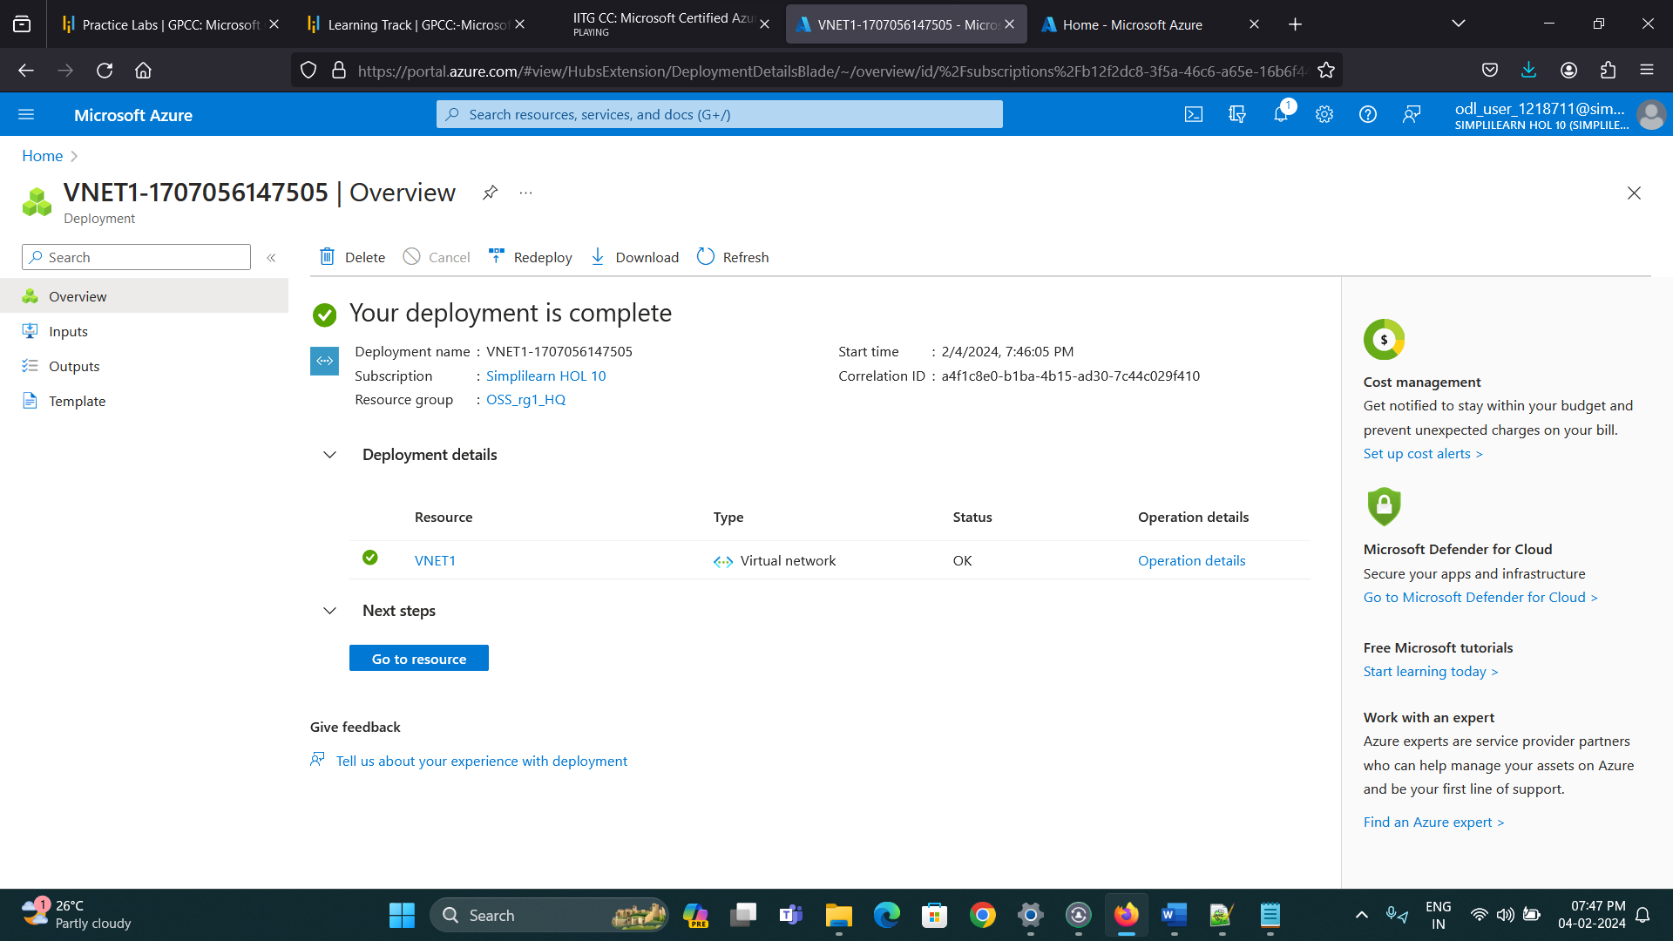

Step B: Create Second Virtual Network in (West us) Region

CIDR VNET: 192.168.0.0/16 CIDR Subnet: 192.168.0.0/24

Resource Group Name: OSS_rg1_HQ

VNET Name: VNET2

Subnet Name: SN2

Location: West Us

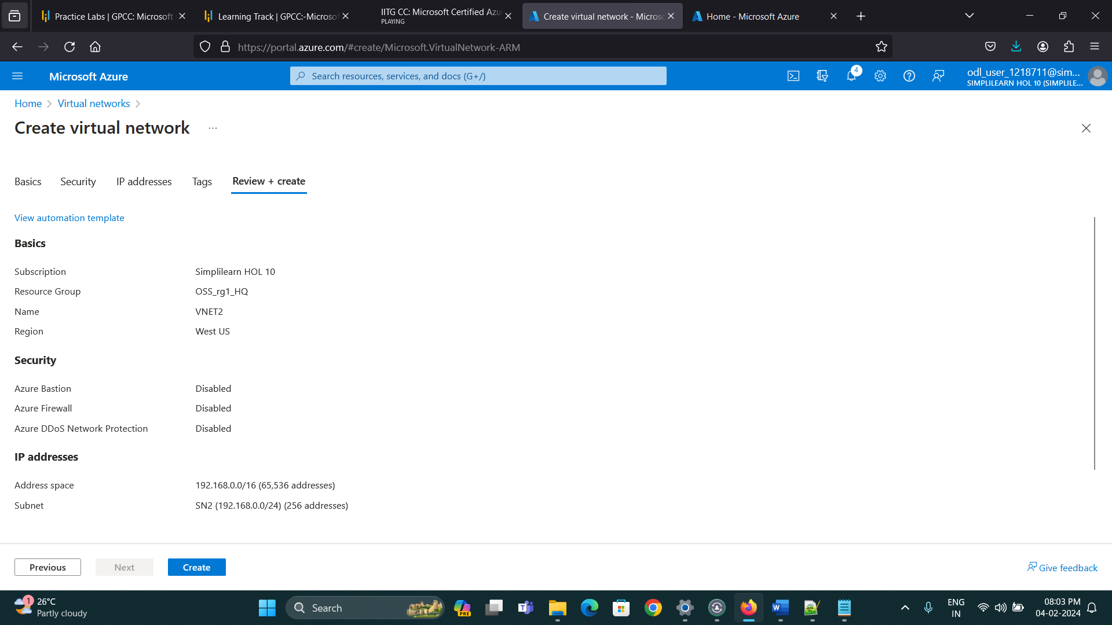

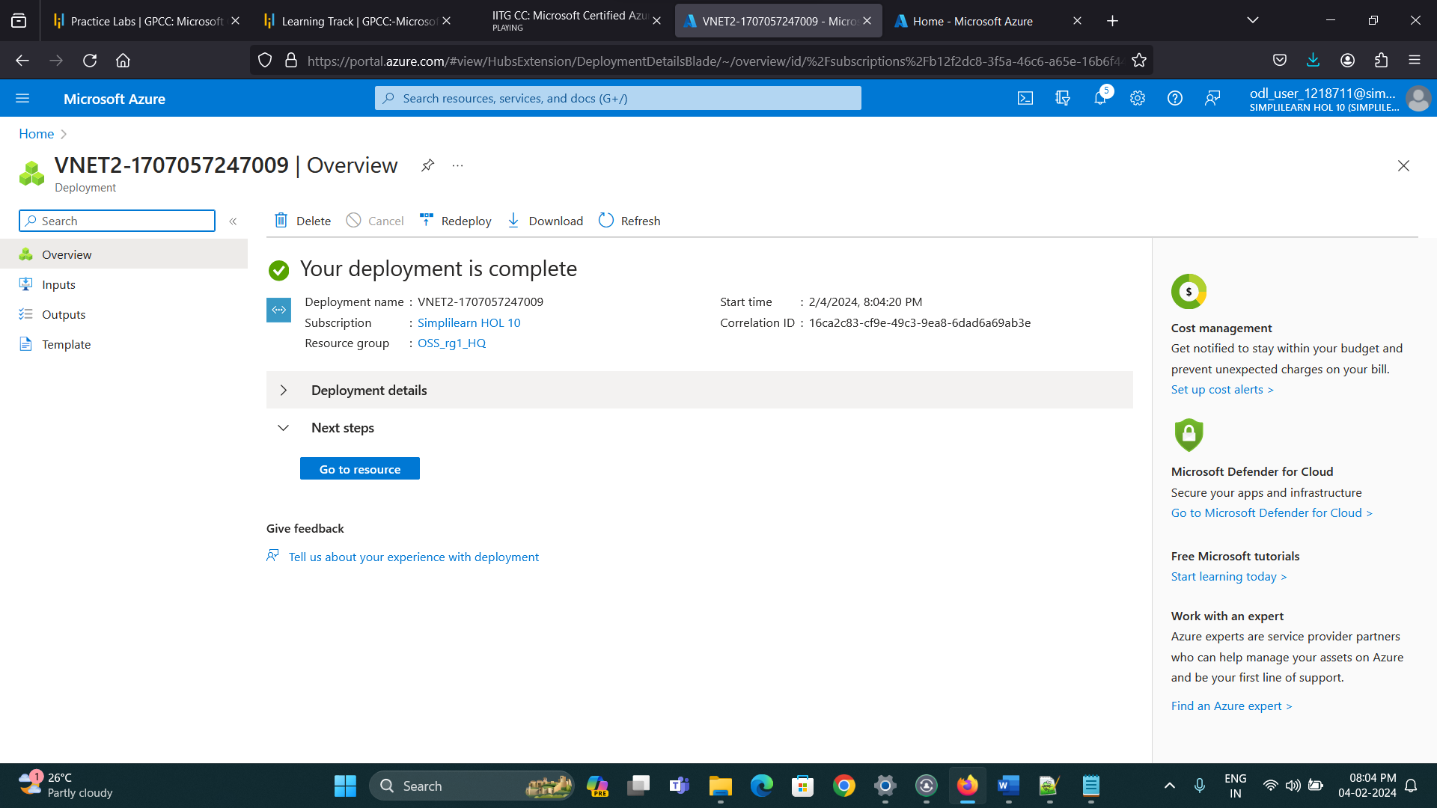

Step2: Create test virtual machines in both the virtual networks

Step A: Create First Virtual Machine in (East US) Region

Resource Group Name: OSS_rg1_HQ

Virtual Machine Name: VM1

VNET Name: VNET1

Subnet Name: SN1

Location: East US

OS Type: Windows 2016

Datacenter-Gen2 Instance Size: Standars_D2S_v3

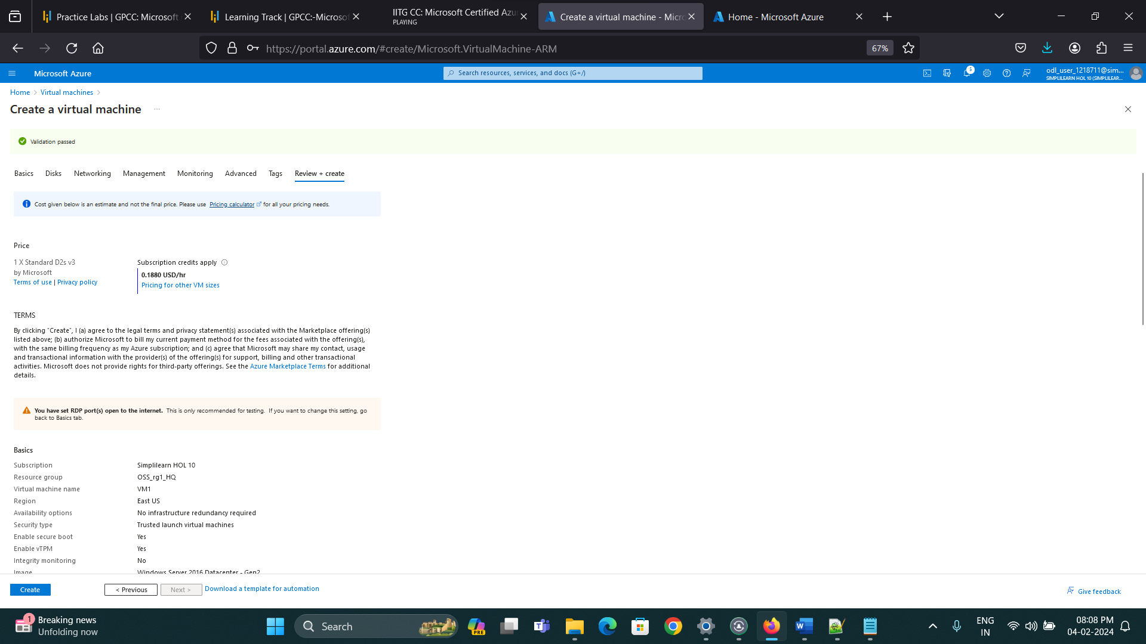

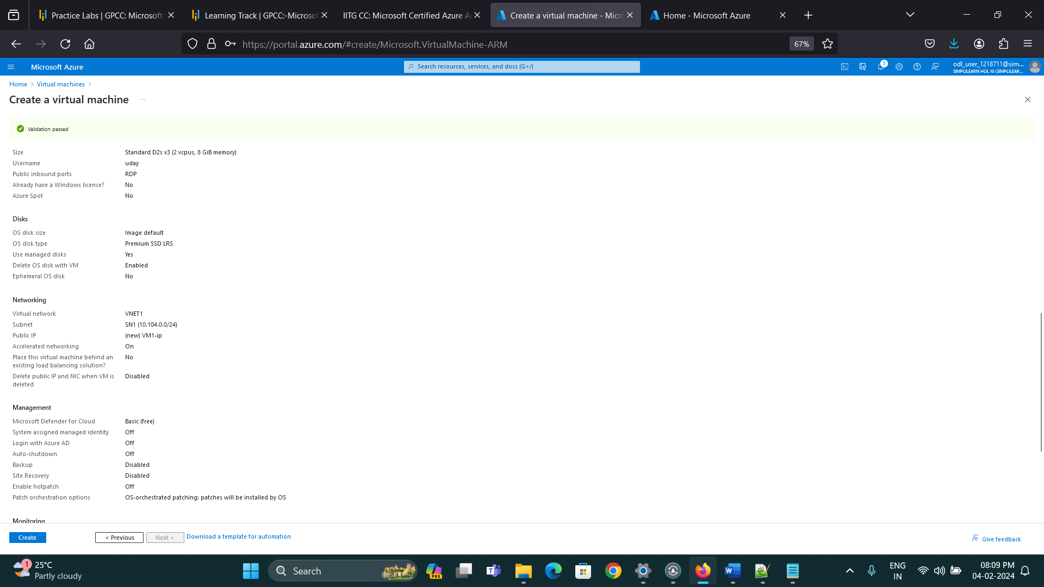

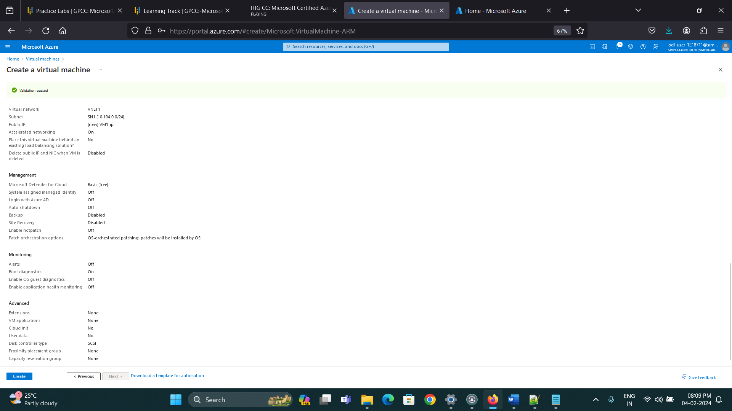

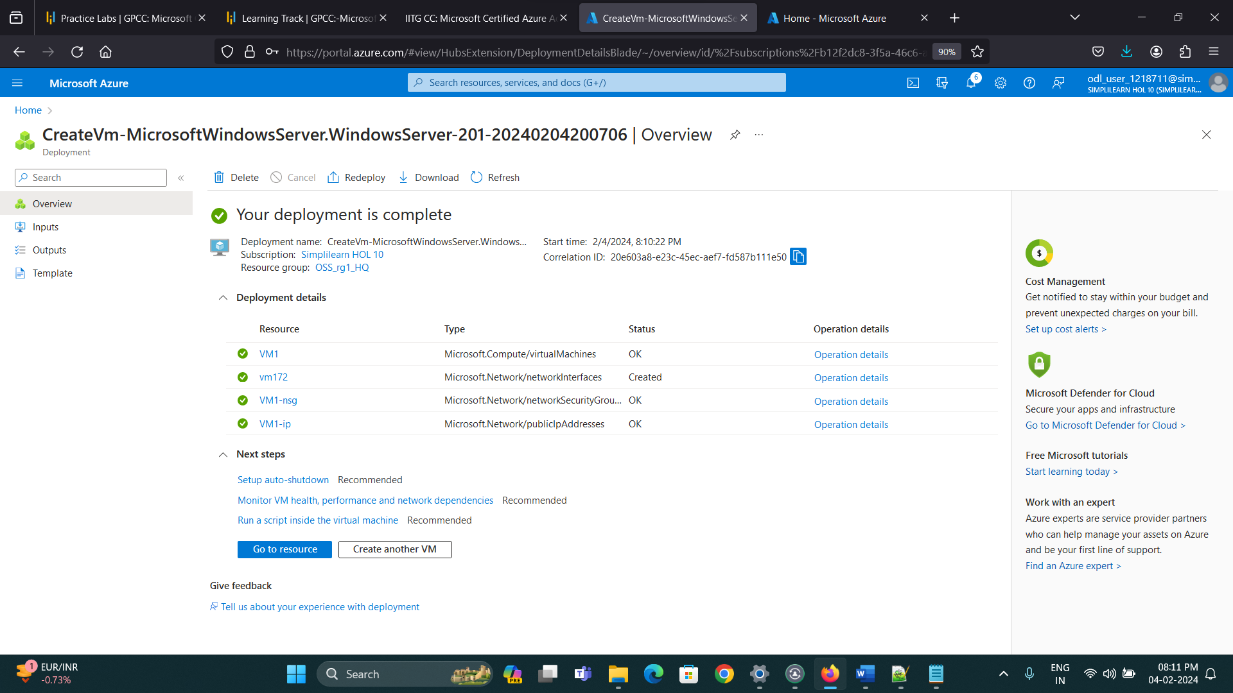

Step B: Create Second Virtual Machine in (West US) Region

Resource Group Name: OSS_rg1_HQ

Virtual Machine Name: VM2

VNET Name: VNET2

Subnet Name: SN2

Location: West US

OS Type: Windows 2016 Datacenter-Gen2

Instance Size: Standard_D2S_v3

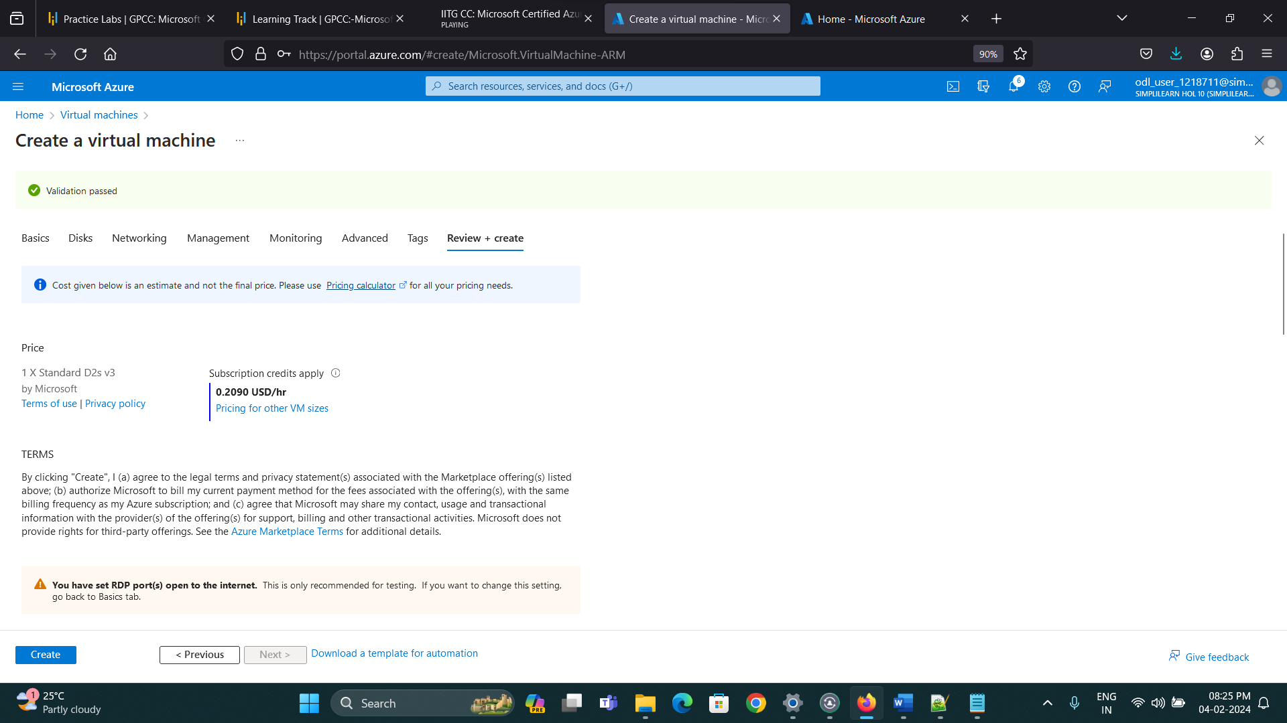

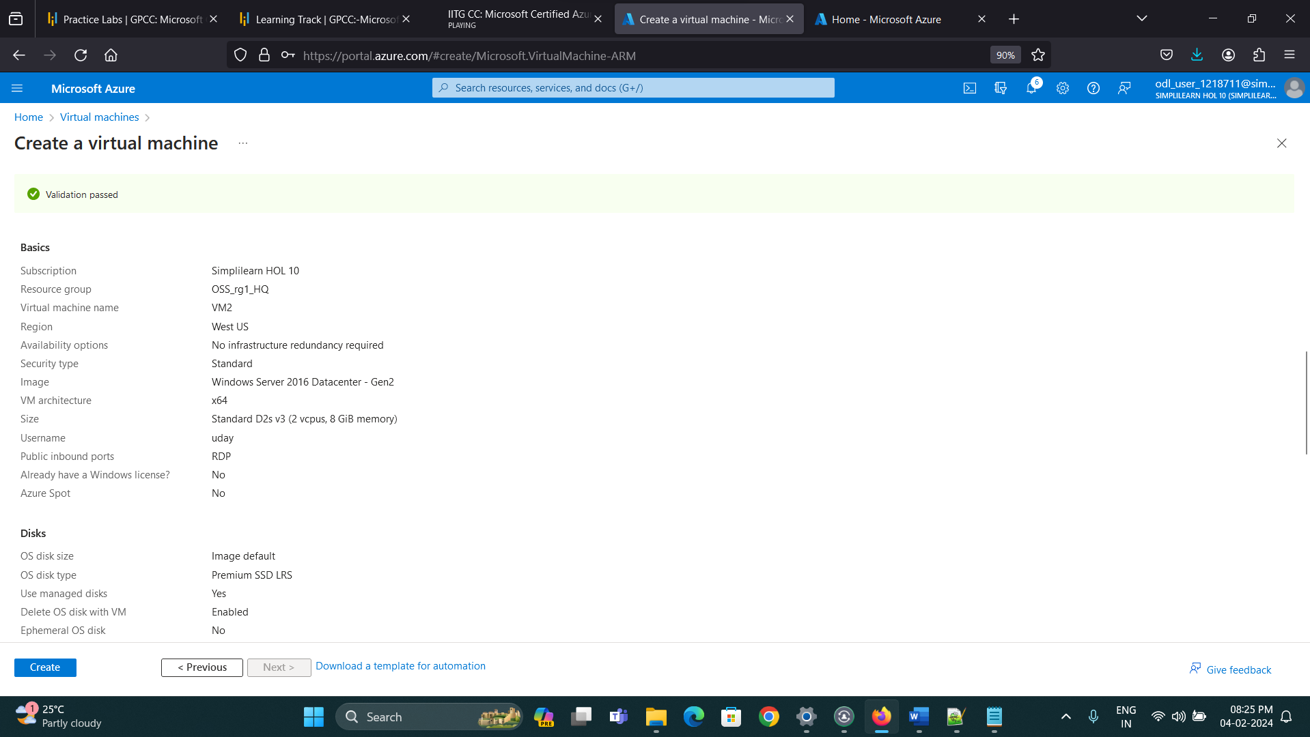

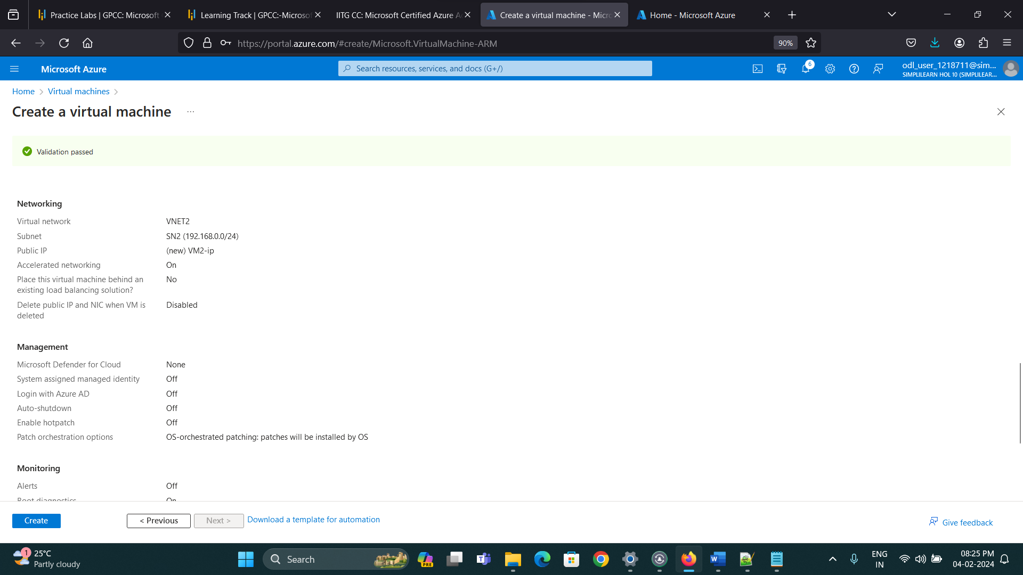

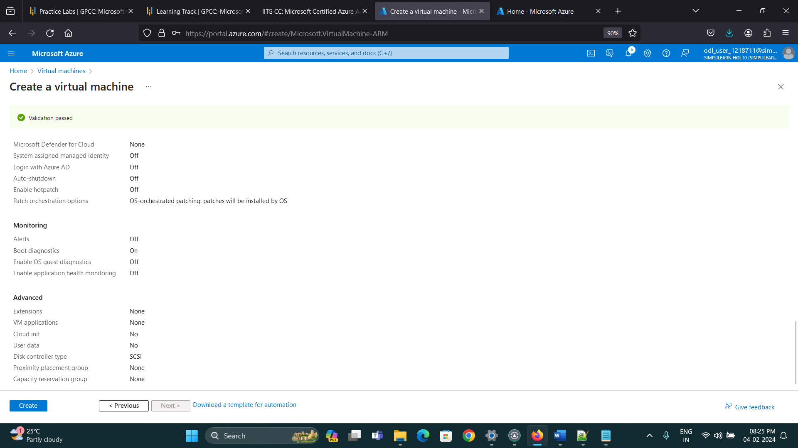

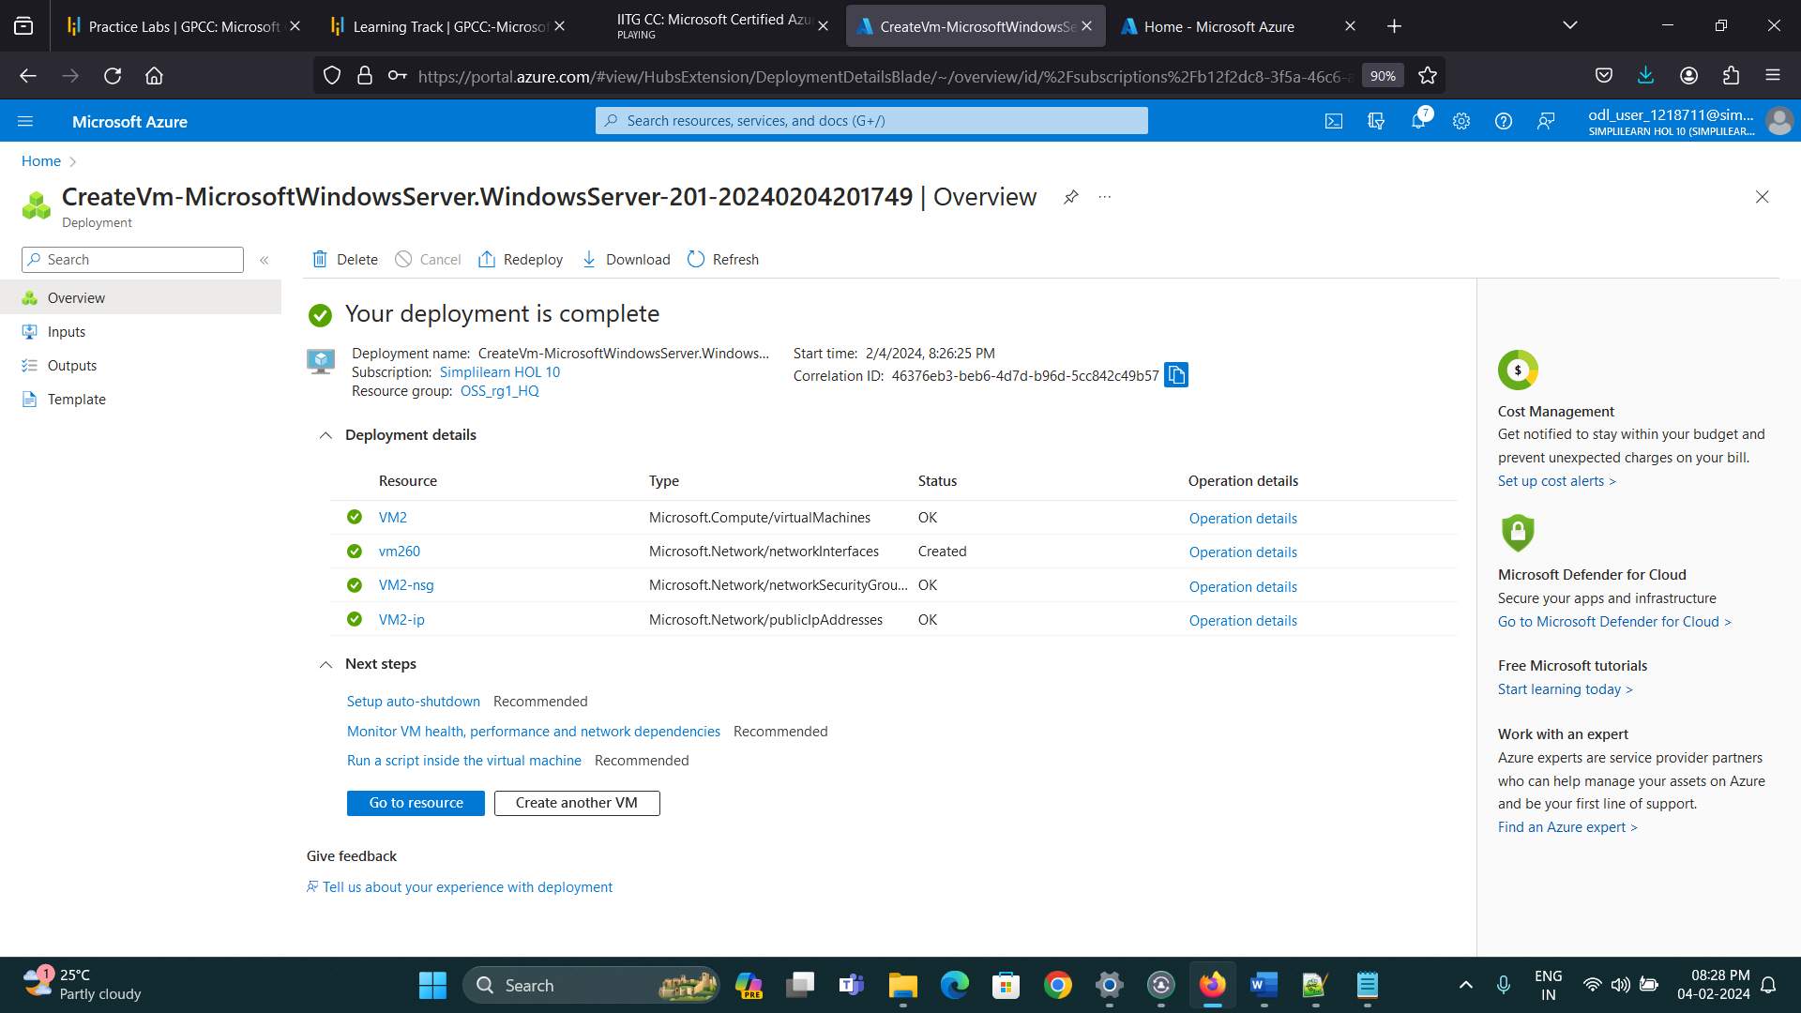

Step 3: Establish the connectivity between both the networks via VNet peering

A. First go to virtual Networks Tab

B. Go to First Virtual Network i.e. VNET1

C. Go to peering’s tab in VNET1

D. Click on Add and do the settings for VNET Peering

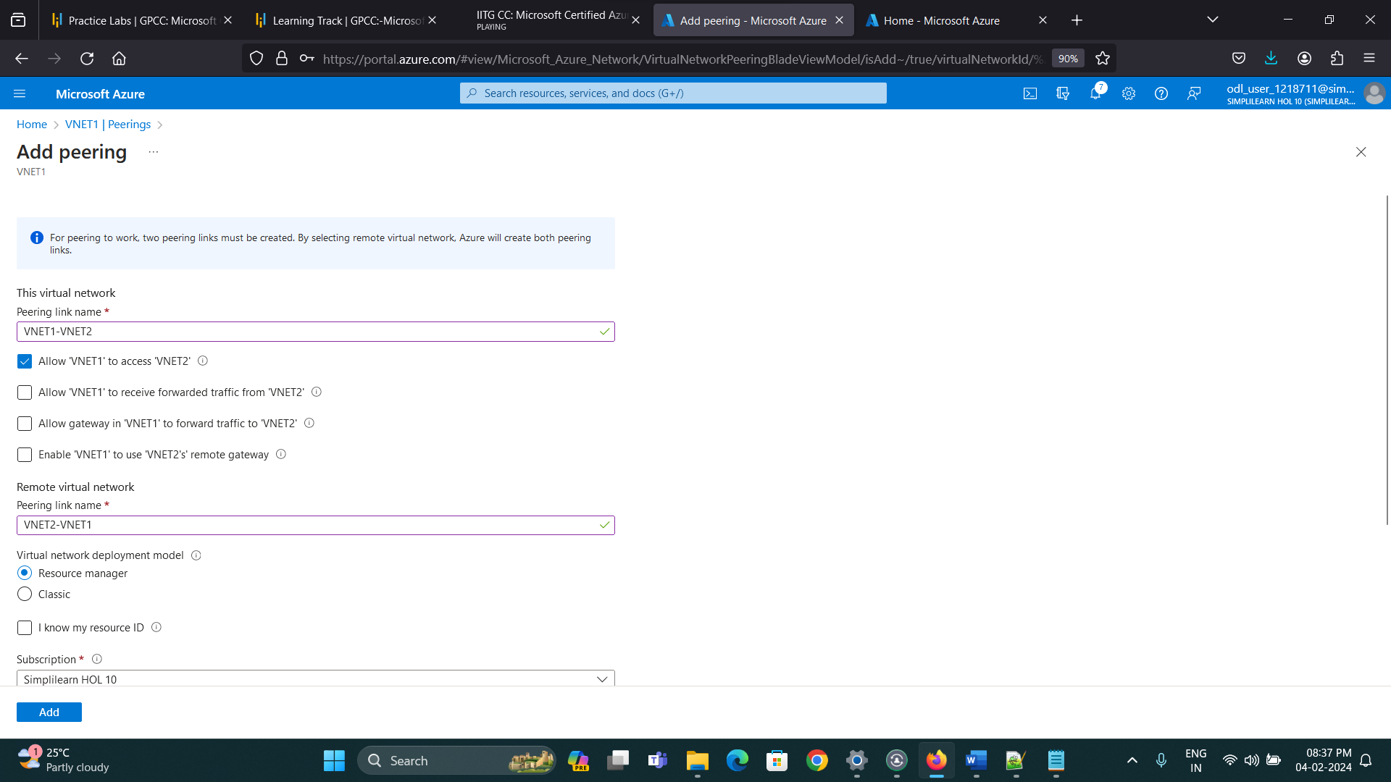

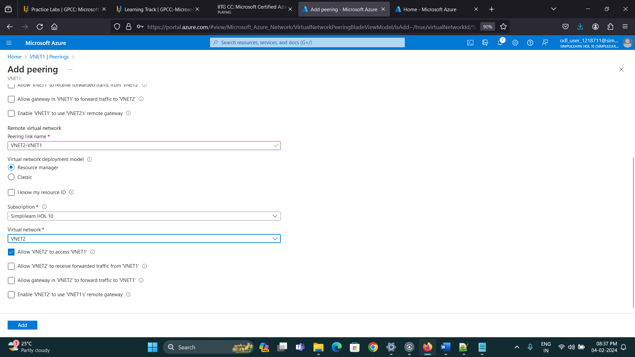

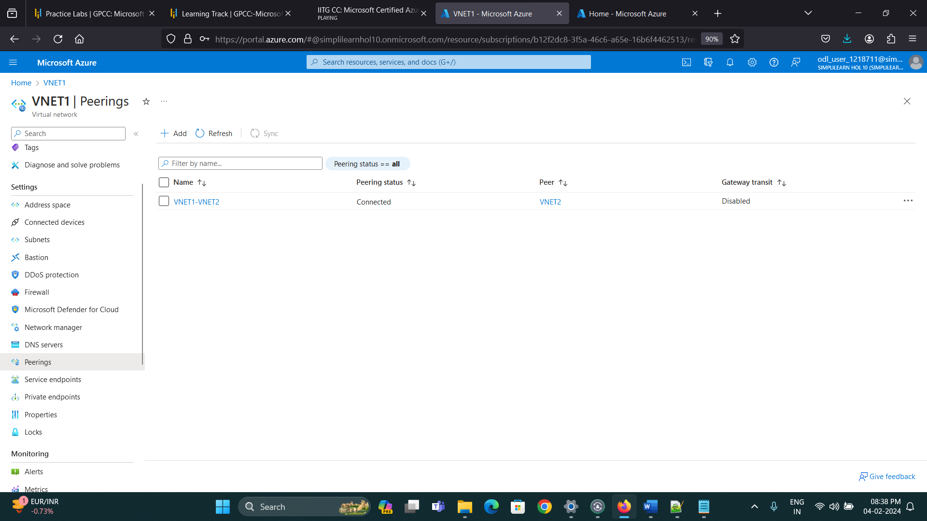

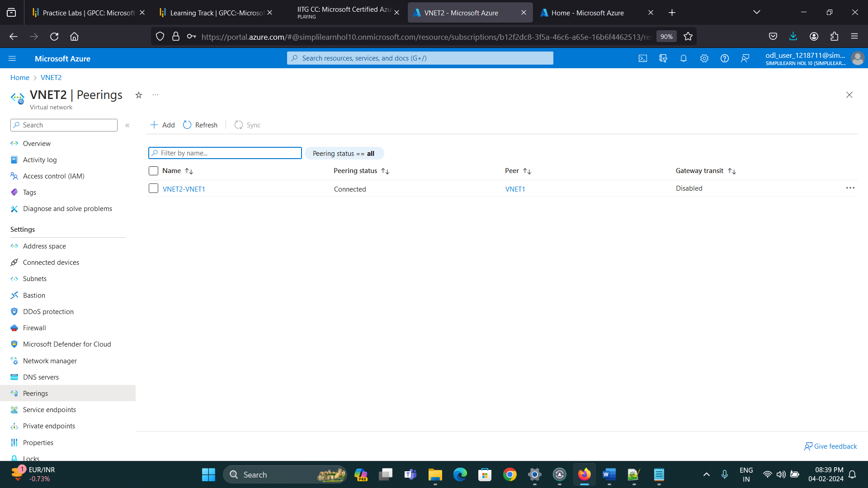

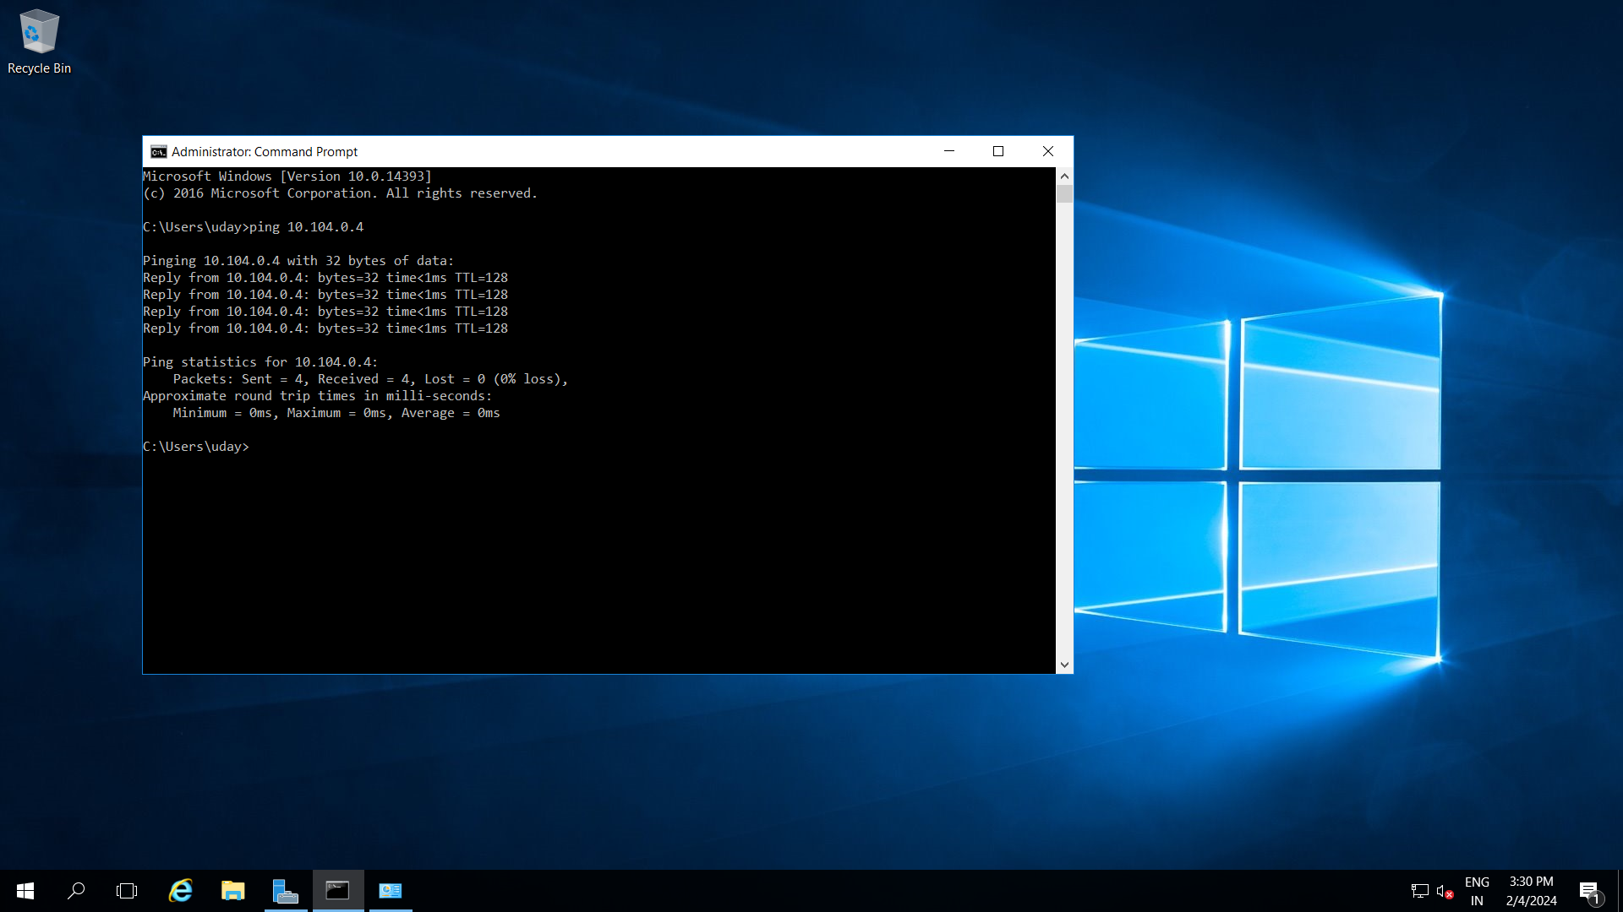

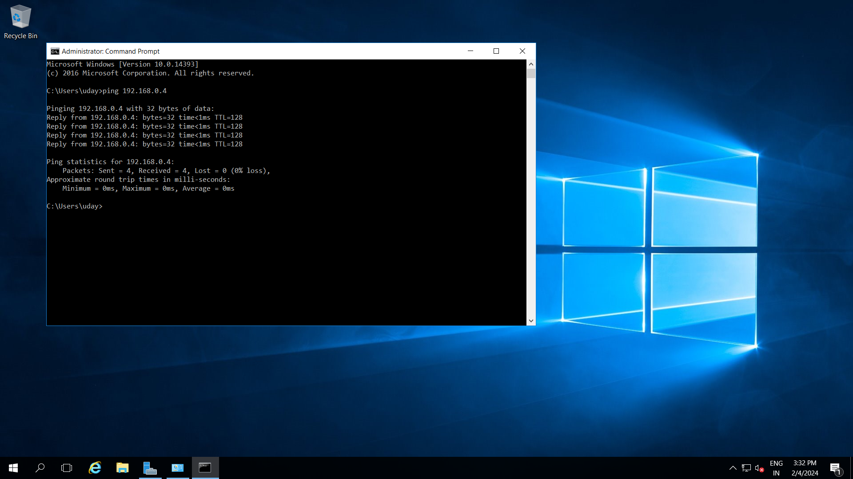

Step 4: Onboard User

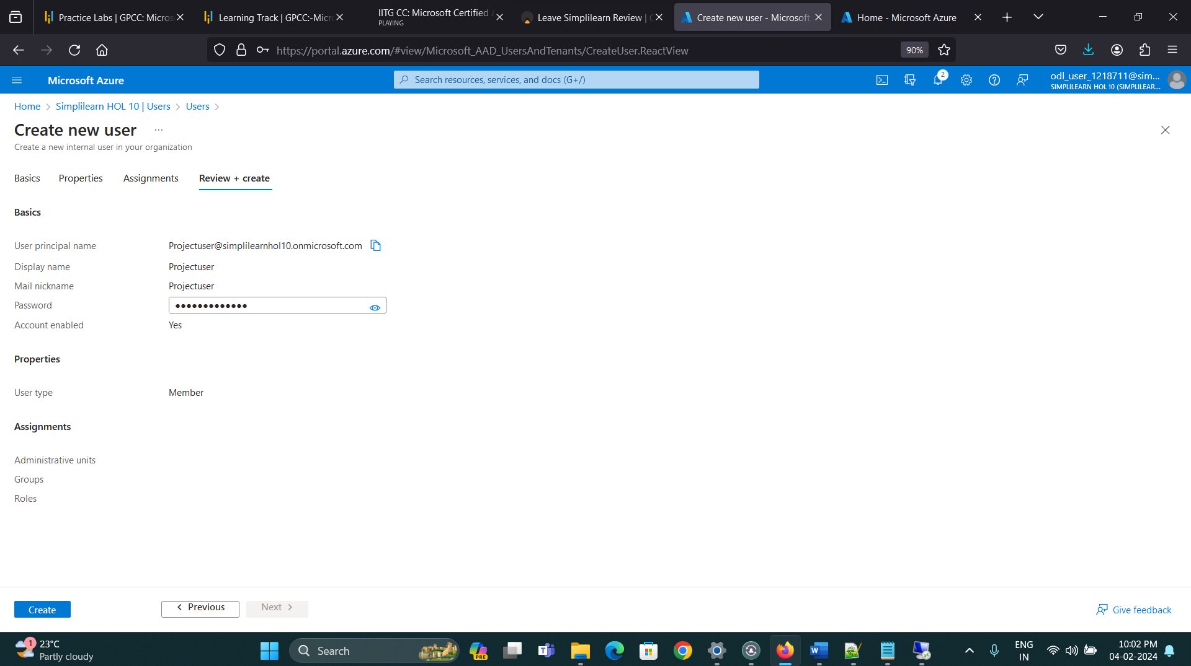

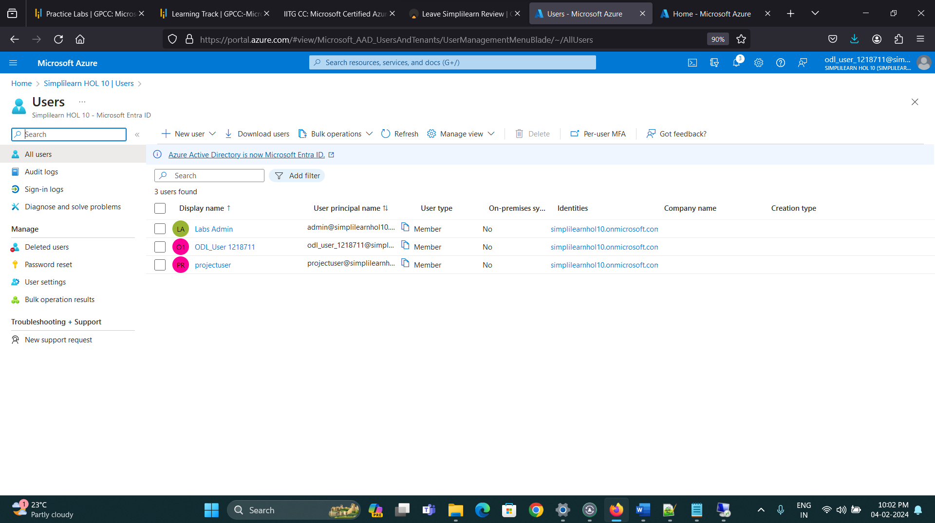

Step 5: Create and assign a custom role to the user.

